PRACTICAL -06
Aim:
Implementation of chain matrix multiplication using dynamic programming.

Theory:
The Matrix Chain Multiplication problem asks for the most efficient way to multiply a sequence of matrices. Matrix multiplication is associative, so the order of parenthesization does not change the final product. It does change the number of scalar multiplications needed. Multiplying a matrix of size p × q by one of size q × r takes p × q × r scalar multiplications. The goal is not to multiply the matrices, but to find the parenthesization that needs the fewest scalar multiplications.
For example, with A (10×30), B (30×5) and C (5×60), the order (AB)C costs 4,500 multiplications, while A(BC) costs 27,000. The choice of order matters a great deal.
Dynamic Programming solves this efficiently because the problem has optimal substructure and overlapping subproblems. The optimal way to multiply Ai…Aj must split the chain at some point k, and the two sub-chains Ai…Ak and Ak+1…Aj must themselves be multiplied optimally. A brute-force approach would recompute the same sub-chains many times, giving exponential time.
The dimensions are stored in an array p, where matrix Ai has dimensions p[i] × p[i+1]. A table dp[i][j] stores the minimum cost of multiplying matrices i through j:
- dp[i][i] = 0, since a single matrix needs no multiplication.
- dp[i][j] = min over i ≤ k < j of { dp[i][k] + dp[k+1][j] + p[i] × p[k+1] × p[j+1] }
The table is filled bottom-up in increasing order of chain length. This gives a time complexity of O(n³) and a space complexity of O(n²), where n is the number of matrices.
Algorithm:
- Input the dimension array p of size n + 1, where n is the number of matrices and matrix Ai has dimensions p[i] × p[i+1].
- Create an n × n table dp and initialize all entries to 0. The diagonal entries dp[i][i] stay 0 because a single matrix has no cost.
- For each chain length length from 2 to n:
- For each starting index i from 0 to n − length, set j = i + length − 1.
- Set dp[i][j] = ∞.
- For each split point k from i to j − 1, compute
cost = dp[i][k] + dp[k+1][j] + p[i] × p[k+1] × p[j+1].
- If cost < dp[i][j], set dp[i][j] = cost.
- After all lengths are processed, dp[0][n−1] holds the minimum number of scalar multiplications for the whole chain.
- Display dp[0][n−1].

Program Code:
def matrix_chain_dp(p):
n = len(p) - 1

# dp[i][j] = minimum cost of multiplying matrices
# from matrix i to matrix j
dp = [[0 for _ in range(n)] for _ in range(n)]

# length is the chain length
for length in range(2, n + 1):
for i in range(n - length + 1):
j = i + length - 1

# Set initial cost to infinity
dp[i][j] = float('inf')

# Try every possible split point
for k in range(i, j):
cost = (dp[i][k] +
dp[k + 1][j] +
p[i] * p[k + 1] * p[j + 1])

dp[i][j] = min(dp[i][j], cost)

return dp[0][n - 1]

# Demo
if __name__ == "__main__":

# Matrices:
# A1 = 2 x 3
# A2 = 3 x 4
# A3 = 4 x 5
# A4 = 5 x 6
p = [6, 5, 3, 4, 3]

print("Minimum number of scalar multiplications:",
matrix_chain_dp(p))
Output:
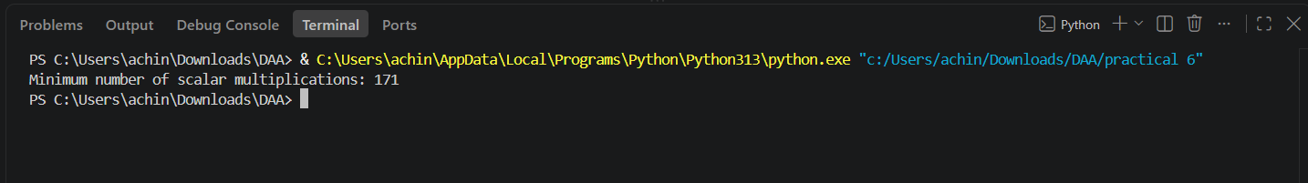

Result:
The program successfully solves the Matrix Chain Multiplication problem using Dynamic Programming. For the input p = [6, 5, 3, 4, 3], which represents four matrices of sizes 6×5, 5×3, 3×4 and 4×3, the minimum number of scalar multiplications is 171. This corresponds to the parenthesization A1 × (A2 × (A3 × A4)). The bottom-up table avoids recomputing sub-chains, so the algorithm runs in O(n³) time and O(n²) space, compared with the exponential time of the naive recursive approach.

